**Lab Assignments**

**Digital Image Processing**



Submitted by: Submitted to:

Ajay Singh Dr. Bhupendra Singh Kirar

(20U03058) (Professor)

Indian Institute of Information Technology, Bhopal

**Department of Information Technology**

Digital Image Processing (IT-312)

Bachelor of Technology

3rd Year, 5th Semster

**Assignment 1**

a) Capture your own colour image and save it in .jpeg file format.

b) Convert colour image in RGB image.

c) Display colour image and converted grey image in a same figure.

d) Extract the complete information of the image.

**Solution –**

**MATLAB-Code:**

X = im2double(imread('Ajay.jpg'));

R = X(:,:,1);

G = X(:,:,2);

B = X(:,:,3);

z = zeros(size(R));

Rimg = cat(3, R, z, z);

Gimg = cat(3, z, G, z);

Bimg = cat(3, z, z, B);

subplot(3,2,1), imshow(X);

subplot(3,2,2), imshow(Rimg);

subplot(3,2,3), imshow(Gimg);

subplot(3,2,4), imshow(Bimg);

grayImg = rgb2gray(X);

subplot(3,2,5), imshow(grayImg);

info = imfinfo("Ajay.jpg");

imageinfo(info);

**Output:**

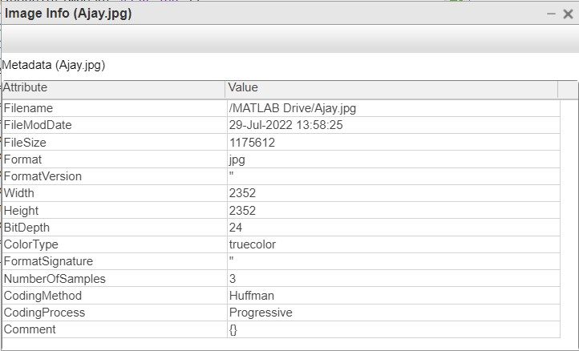

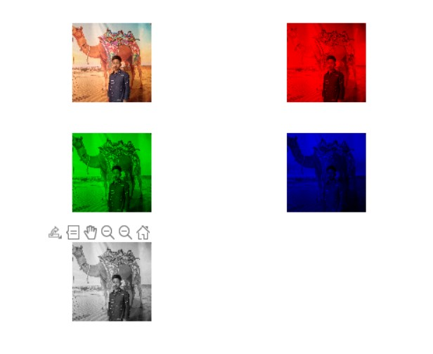

**Assignment 2**

a) Take an input image of skin cancer and increase the image quality using pre-processing techniques.

b) Extract the region of interest (ROI).

c) Download five images and run above programs with the help of loops for 5 images.

**Solution:**

**MATLAB Code:**

**Tutorial 3**

a) Take your own picture and show it as it is.

b) Convert colourful image (RGB) to grey and show it.

c) Resize image to 256*256 pixels.

d) Display output grey images for different intensity resolution (256, 128, 64, 32, 16, 4, 2) in a single figure using subplot function.

**Solution:**

**MATLAB Code:**

I1=imread('Ajay.jpg');

I2 = imresize(I1,[256 256]);

I3 = rgb2gray(I1);

subplot(3,3,1), imshow(I1);

subplot(3,3,2), imshow(I3);

I3 = imresize(I3, [128,128]);

subplot(3,3,3), imshow(I3);

I4 = imresize(I3, [64,64]);

subplot(3,3,4), imshow(I4);

I5 = imresize(I3, [32,32]);

subplot(3,3,5), imshow(I5);

I6 = imresize(I3, [16,16]);

subplot(3,3,6), imshow(I6);

I7 = imresize(I3, [8,8]);

subplot(3,3,7), imshow(I7);

I8 = imresize(I3, [4,4]);

subplot(3,3,8), imshow(I8);

I9 = imresize(I3, [2,2]);

subplot(3,3,9), imshow(I9);

**Output:**

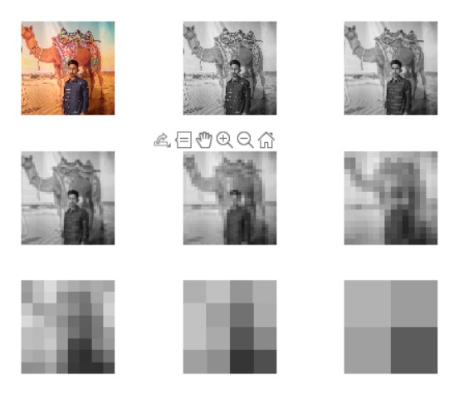

Assignment 7

Interpolation

Shifting MATLAB Code:

I = imread("cameraman.tif");

subplot(3,2,1),imshow(I),title("Original Image");

J = imtranslate(I,[15, 25]);

subplot(3,2,2),imshow(J),title("Translated Image");

K = imtranslate(I,[-15, 25]);

subplot(3,2,3), imshow(K), title("Trnslated Image");

L = imtranslate(I,[-15, -25]);

subplot(3,2,4), imshow(L), title("Trnslated Image");

M = imtranslate(I,[15, -25]);

subplot(3,2,5), imshow(M), title("Trnslated Image");

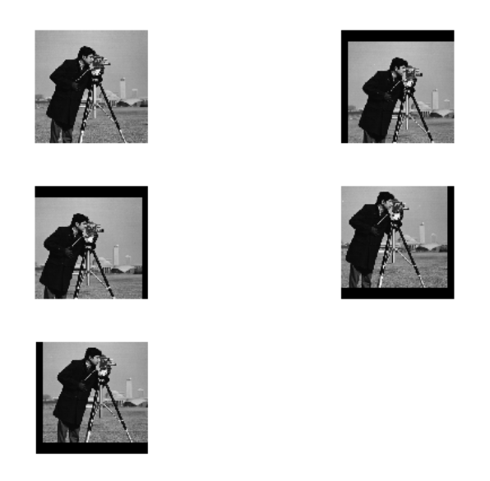

Rotating:

I = imread('cameraman.tif');

subplot(3,2,1), imshow(I), title("Original Image");

J = imrotate(I, 45);

subplot(3,2,2), imshow(J), title("Rotated Image 45degree");

K = imrotate(I, 90);

subplot(3,2,3), imshow(K), title("Rotated Image 90degree");

L = imrotate(I, 180);

subplot(3,2,4), imshow(L), title("Rotated Image 180degree");

M = imrotate(I, 270);

subplot(3,2,5), imshow(M), title("Rotated Image 270degree");

